Dominic Bumpus Library Design Exercise
Dominic Bumpus
Trine University
SYS—5013-301
Dr. Kelly Wibbenmeyer
October 10, 2025

Scenario Overview
The Metropolitan City Library wants to modernize its services by introducing a digital E-Library system accessible via desktop, tablet, and mobile devices. The design must be intuitive and welcoming to users, as well as older patrons who may be unfamiliar with digital interfaces. The system must be built with cognitive load, error prevention, and recovery in mind.

Interface Design Overview
The E-Library’s main interface includes clear sections such as a top navigation bar, search bar, content sections for Latest Arrivals, Recommended for You, and Categories. The layout ensures easy navigation and reduces cognitive load by using familiar visual structures and consistent design patterns. The design of the system also flows easily on a mobile device or a tablet.
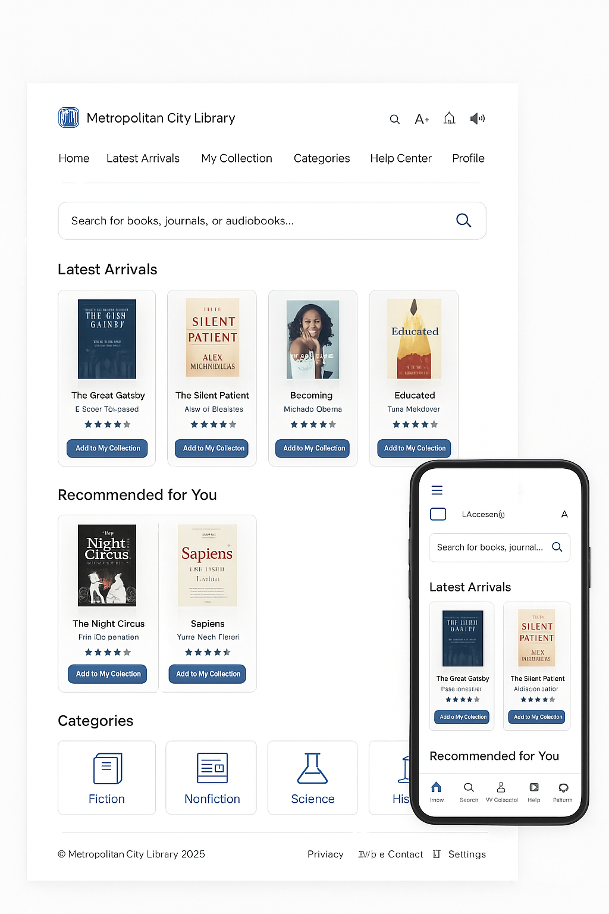

Explanation of Design Choices
A clean and uncluttered layout ensures users can focus on core tasks such as searching, browsing, and borrowing materials. Categorized sections and consistent icons minimize the learning curve across devices. Confirmation messages and loading animations provide real-time feedback when content is accessed or downloaded. Uniform icons, button colors, and font choices across devices improve familiarity and ease of use. Search suggestions, confirmation prompts, and undo options help prevent and correct mistakes effortlessly. High-contrast mode, adjustable text sizes, and voice-assisted navigation enhance usability for all users. Finally, the responsive design ensures smooth experience across desktop, tablet, and mobile screens.

Conclusion
This E-Library interface prioritizes ease of use, consistency, and accessibility, allowing users of all ages and technology skill levels to navigate comfortably. By integrating human-computer interaction principles such as cognitive load reduction, consistency, and effective feedback, the system promotes a seamless and enjoyable digital reading experience. With common features such as profiles, collections, search bar, and a familiar style of UI, the system itself has familiarity immediately to users which helps in usability. Overall, the design of the system meets the requirements and goals of the Metropolitan Library

References
GeeksforGeeks. (2025, July 23). Introduction to Human Computer Interaction (HCI). GeeksforGeeks. https://www.geeksforgeeks.org/system-design/introduction-to-human-computer-interface-hci/
Kendall, K. E., & Kendall, J. E. (2024). Systems Analysis & Design. Pearson.

